Bank Loan Project Query Document
Use [Bank Loan DB];
- TOTAL LOAN APPLICATION
Select COUNT(id) As Bank_Loan_Applications from [Bank_loan Data] ;
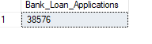
MTD LOAN APPLICATION
Select COUNT(id) As MTD_Bank_Loan_Applications from [Bank_loan Data]
Where MONTH(issue_date)= 12 and YEAR(issue_date)=2021;
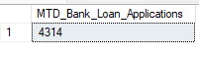
PMTD LOAN APPLICATION
Select COUNT(id) As PMTD_Bank_Loan_Applications from [Bank_loan Data]
Where MONTH(issue_date)= 11 and YEAR(issue_date)=2021;
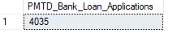
- TOTAL FUNDED AMOUNT
Select Sum(loan_amount) As Total_Funded_Amount_Query From [Bank_loan Data];
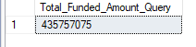

MTD TOTAL FUNDED AMOUNT
Select Sum(loan_amount) As Total_Funded_Amount_Query From [Bank_loan Data]
Where Month(issue_date)=12 and Year(issue_date)=2021;
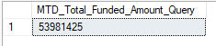
PMTD TOTAL FUNDED AMOUNT
Select Sum(loan_amount) As Total_Funded_Amount_Query From [Bank_loan Data]
Where Month(issue_date)=11 and Year(issue_date)=2021;
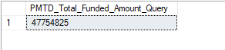

- TOTAL LOAN AMOUNT RECEIVED
Select Sum(total_payment) As Total_Amount_Received From [Bank_loan Data];
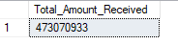

- AVERAGE INTEREST RATE OF LOAN
Select Round(AVG(int_rate),4) * 100 As Average_Interest_Rate From [Bank_loan Data];
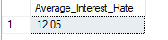

MTD AVERAGE INTEREST OF LOAN
Select Round(AVG(int_rate),4) * 100 As MTD_Average_Interest_Rate From [Bank_loan Data]
Where MONTH(issue_date)=12 and YEAR(issue_date)=2021;
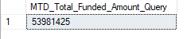
PMTD AVERAGE INTEREST OF LOAN
Select Round(AVG(int_rate),4) * 100 As Average_Interest_Rate From [Bank_loan Data]
Where MONTH(issue_date)=11 and YEAR(issue_date)=2021;
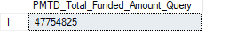
- AVERAGE DTI
Select ROUND(AVG(dti),4) *100 As AVG_DTI From [Bank_loan Data];
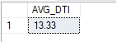
MTD AVERAGE DTI

Select ROUND(AVG(dti),4) *100 As MTD_AVG_DTI From [Bank_loan Data]
Where Month(issue_date)=12 and Year(issue_date)=2021;
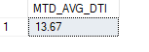
PMTD AVERAGE DTI
Select ROUND(AVG(dti),4) *100 As PMTD_AVG_DTI From [Bank_loan Data]
Where Month(issue_date)=11 and Year(issue_date)=2021;
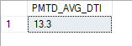
- TOTAL COUNT OF GOOD LOAN CASES

SELECT
Count(*)As Customers_Paid_Loan FROM [Bank_loan Data]
WHERE loan_status = 'Fully Paid';
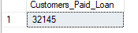

- TOTAL COUNT OF BAD LOAN CASES
SELECT
Count(*)As Customers_NotPaid_Loan FROM [Bank_loan Data]
WHERE loan_status = 'Charged Off';
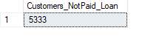
- TOTAL COUNT OF CURRENT LOAN CASES
SELECT
Count(*)As Customers_Current_Loan FROM [Bank_loan Data]
WHERE loan_status = 'Current';
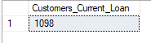

- TOTAL NO OF COUNT GOOD CUSTOMERS WHO REPAY LOAN

SELECT
(COUNT(CASE WHEN loan_status='Fully Paid' OR loan_status = 'Current' THEN id End ))As Customers_Repay_Loan FROM [Bank_loan Data];

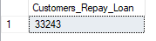

- PERCENTAGE OF GOOD LOAN CASES

SELECT
(COUNT(CASE WHEN loan_status='Fully Paid' OR loan_status = 'Current' THEN id End )*100)
/
COUNT(id) As Good_Percentage_Loan
FROM [Bank_loan Data];
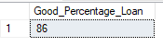

- PERCENTAGE OF BAD LOAN CASES

SELECT
(COUNT(CASE WHEN loan_status='Charged Off' THEN id End )*100)
/
COUNT(id) As Bad_Percentage_Loan
FROM [Bank_loan Data];

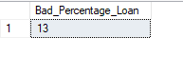

- GOOD LOAN FUNDED AMOUNT

SELECT SUM(loan_amount) As Good_Loan_Funded_Amount FROM [Bank_loan Data] where loan_status='Fully Paid' OR loan_status='Current'

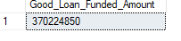

- BAD LOAN FUNDED AMOUNT

SELECT SUM(loan_amount) As Bad_Loan_Funded_Amount FROM [Bank_loan Data] where loan_status='Charged Off'

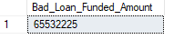

- GOOD LOAN RECEIVED AMOUNT

SELECT
SUM(total_payment) As Good_Loan_Received_Amount FROM [Bank_loan Data] where loan_status='Fully Paid' OR loan_status='Current'

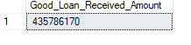

- BAD LOAN RECEIVED AMOUNT

SELECT
SUM(total_payment) As Bad_Loan_Received_Amount FROM [Bank_loan Data] where loan_status='Charged Off'

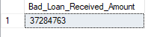

- GOOD LOAN APPLICATIONS

SELECT
COUNT(id) As Good_Loan_Applications FROM [Bank_loan Data] where loan_status='Fully Paid' OR loan_status='Current'

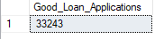

- BAD LOAN APPLICATIONS

SELECT COUNT(id) As Bad_Loan_Applications FROM [Bank_loan Data] where loan_status='Charged Off'

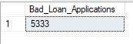

- LOAN STATUS

SELECT
loan_status,
Count(id) As Emp_ID_COUNT,
SUM(total_payment) As TOTAL_AMT_RECEIVED,
SUM(loan_amount) As TOTAL_FUNDED_AMT,
Avg(int_rate) As AVG_RATE_OF_INTEREST,
Avg(dti*100) As DTI
From [Bank_loan Data]
Group By
loan_status;
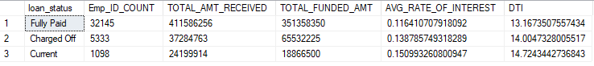

- LOSS AMOUNT OF BANK

SELECT
SUM(loan_amount) - SUM(total_payment) AS Loss_Amount
FROM [Bank_loan Data]
WHERE loan_status = 'Charged Off';
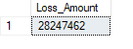
- PROFIT AMOUNT RECEIVED BY BANK

SELECT
SUM(total_payment)- SUM(loan_amount) As Profit_Amount
FROM [Bank_loan Data]
WHERE loan_status = 'Fully Paid' OR loan_status ='Current';

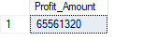

- Top 5 Good Customers
SELECT TOP 5
id,
last_payment_date,
loan_status,
member_id,
purpose,
loan_amount
From [Bank_loan Data]
Where loan_status='Fully paid' and loan_amount>25000
ORDER BY loan_amount DESC;
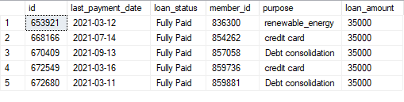

- TOP 5 Bad Customers

SELECT *
FROM (
Select
id,
last_payment_date,
loan_status,
member_id,
purpose,
loan_amount,
ROW_NUMBER() OVER (ORDER BY loan_amount DESC) AS rank
FROM [Bank_loan Data]
WHERE loan_status = 'Charged Off'
AND loan_amount >=35000
) AS ranked_loans
WHERE rank <= 5;
